# Tutorial #2 - Add Hits

## Overview

This tutorial will show a few examples of how to use both variables and functions to create some basic achievements in RAScript. [Streets of Rage 2](https://retroachievements.org/game/3) was chosen as the tutorial example to show how adding hits can be used to improve counting the number of enemies the player has knocked out.\

![Streets of Rage 2 Title Screen](Streets_of_Rage_Title.png)\

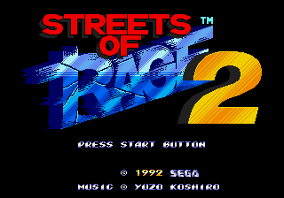

## AddHits

Each comparison in achiement logic is evaluated every frame. By default each comparison is set to 0 *hits* which means that the comparison will not remember its previous evaluations. For the achievement to be triggered the comparison with 0 hits must evaluate true in the same frame as the rest of the comparisons in the achievement. If the comparison is set to one or more *hits*, then the comparison will keep track of how many frames that the comparison evaluated to true. Once number of *hits* equals the initial *hits* setting then the comparison will remain true until either the achievement is triggered or reset.\

\

In some case you’ll want to combine *hits* together from multiple comparisons. The following examples will show how to add hits together for tracking which characters the player has used and to count how many enemies the player has knocked out. This tutorial will use a few different type of RAScript *hits* related commands which can be found on the RATools wiki in the [Trigger-Functions](<https://github.com/Jamiras/RATools/wiki/Trigger-Functions>) section.

## Example 2A - Team Game

Street of Rage 2 has four playable characters: Max, Axel, Blaze, and Skate. Each character has their own statistics and abilities that are significantly different enough to require a different strategy for each character. You are given the chance to select a character once at the beginning of the game and you may change your selection after continuing.\

![Character selection screenshot with Skate selected](Skate_Select.png)\

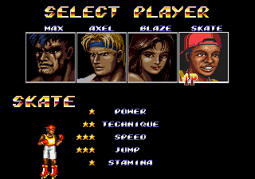

The following code will track that you’ve played with each character at least once. The achievement will pause with the *unless* command whenever the screen mode is not in game. That way we don’t trigger hit during the character selection screen and the player must use the character in game. Using the *once* command the player selected comparison will latch on when the character is selected and stay on indefinitely. When using hits you’ll would usually want include a *never* statement to reset the logic however, in this case we don’t need to reset the logic. Note that the hits would all be reset in a new session.

```

// Streets of Rage 2

// #ID = 3

// $FC02: Screen Mode- 0=segalogo, 4=pressstart, 8=demo, c=mainmenu, 10=options, 14=ingame, 18=charselect, 1c=ending, 24=introcards, 28=credits

function ScreenMode() => byte(0x00FC02)

// $FC50: Axel selected = 0xff

function AxelSelected() => word(0x00FC50)

// $FC51: Max selected = 0xff

function MaxSelected() => word(0x00FC51)

// $FC52: Skate selected = 0xff

function SkateSelected() => word(0x00FC52)

// $FC53: Blaze selected = 0xff

function BlazeSelected() => word(0x00FC53)

// Record a hit for each character active during gameplay

// This variation is the current core achievement

achievement(

title = "Team Game",

description = "Play once as every character",

points = 4,

trigger = unless(ScreenMode() != 20) &&

once(AxelSelected() == 255) &&

once(BlazeSelected() == 255) &&

once(MaxSelected() == 255) &&

once(SkateSelected() == 255)

)

```

The above works perfectly fine for tracking which players are used. A measure could be added to this function to give the player some feedback of how many characters they have used. To add the measure we will need to combine the hits using the *tally* function. Since the pause would disable the achievement while not in-game another modification was made to check the game mode with the selected player at the same time. When two or more comparisons are combined together like this in an *once* command they are grouped together with *AndNext* flags. So the result of this follow code is a *AddHits* and *AndNext* chain that will add to four when every player has been selected.

```

// Record a hit for each character active during gameplay

// This variation of the using add hits to support using measure

achievement(

title = "Example 2A: Team Game",

description = "Play once as every character",

points = 0,

trigger = measured(

tally(4,

once(ScreenMode() == 20 && AxelSelected() == 255),

once(ScreenMode() == 20 && MaxSelected() == 255),

once(ScreenMode() == 20 && SkateSelected() == 255),

once(ScreenMode() == 20 && BlazeSelected() == 255)

)

)

)

```

## Example 2B

Streets of Rage - Untouchable

Defeat 200 enemies without dying

https://retroachievements.org/achievement/308

## Example 2C

Homework

Streets of Rage - Steel Grip

Defeat 10 enemies without dropping your weapon

https://retroachievements.org/achievement/55